Inflation Dynamics and Relative Price
Dispersion in South Africa: Implications for
Optimal Inflation Targeting

Keagile Lesame Xolani Sibande

March 16, 2026

This paper investigates the dynamic relationship between inflation and relative price dispersion (RPD) in South Africa, focusing on the period from 2009 to 2025, a timeframe marked by significant structural changes in inflation targeting. Drawing on both theoretical models—the menu cost and signal extraction frameworks—the study tests their predictions on how inflation influences RPD using a semi-parametric approach. It extends the analysis by employing quantile-on-quantile regression to capture state-dependent effects across the distribution of relative price variability. The South African case is particularly insightful due to its evolving inflation targets, transitioning from a 3-6 percent band (2000) to a 4.5 percent midpoint target (2017), and moving towards a 3 percent target projected for 2025. These policy shifts offer a unique opportunity to explore the nonlinear, U-shaped nature of the inflation-RPD relationship, challenging the traditional view that zero inflation is optimal. Empirically, this study contributes to the scant emerging market literature, complementing prior work but incorporating inflation target changes. The findings have important implications for monetary policy design in emerging economies aiming to lower inflation targets while minimizing distortive effects on price signals and resource allocation.

Keywords: Relative Price Dispersion, Inflation, Monetary Policy
JEL-Codes: E31, E52, E58
∗

Introduction
Inflation is known to have adverse welfare effects through its distortion of relative prices which causes the misallocation of resources, production inefficiencies leading to lower real economic activity. This is well supported by both theoretical and empirical studies. This paper contributes to the empirical literature, by examining the relationship between inflation and relative price dispersion (RPD) in South Africa given the little evidence available and to determine how the relationship has evolved given inflation target changes and its implications for monetary policy.
The South African context can provide further insights into the relationship between inflation and RPD given the changes in the inflation targets from a 3 to 6 per cent band in 2000 to a 4.5 per cent midpoint target since 2017 and a shift to 3 per cent inflation target in 2025 as structural changes in inflation can affect the linkages with relative price dispersion (Caglayan and Filiztekin 2003). Furthermore, the functional form of relationship is U-shaped and dynamic (Fielding and Mizen 2000; Choi 2010) implying a non-zero optimal inflation rate that minimizes the distortive effect on relative prices since a linear relationship would imply that the optimal inflation rate is zero. Given the above-mentioned inflation target reforms, South Africa provides an opportunity to examine the dynamic effects of inflation on relative price variability and the optimal inflation target with policy implications for emerging market economies that intend to transition to lower inflation targets.
The theoretical literature distinguishes between menu-cost and signal extraction models in explaining the positive relation between inflation and RPD. In menu cost models (Sheshinski and Weiss 1979, 1983; Rotemberg 1983; Benabou 1992) firms face fixed cost of adjusting nominal prices (e.g. printing new menus) and since they follow a one-sided dynamic pricing rule (S, s) when setting prices, inflation reduces the optimal real price. Given price adjustment costs differ across firms (e.g. due to differences administrative costs) price adjustment occurs infrequently and at sporadic times leading to staggard price setting and consequently an increase in relative price variability with the latter reflecting nominal rigidities rather than a scarcity of resources. Signal extraction models emphasize the role of inflation surprises in increasing RPD. In these models, under the assumption of imperfect information, firms observe their own prices immediately, but only observe aggregate prices imperfectly, therefore unexpected inflation or inflation volatility reduces the informational content of prices as firms are unable to distinguish between idiosyncratic relative (real or demand) shocks and aggregate (inflationary) shocks (Lucas 1973; Hercowitz 1981; Cukierman 1983; Barro 1976) leading to cross-sectional price dispersion which results in allocative inefficiencies generating adverse real effects. While menu cost models predict a linear relationship, signal extraction models predict nonlinearities along with monetary search models (Head and Kumar 2005) with the latter also arguing that moderate inflation can increase welfare suggesting the optimal inflation can be non-zero.
Against this backdrop, this paper closely follows Caraballo and Dabús (2013) and tests the menu cost and signal extraction models in a semi-parametric framework (Robinson 1988) for South Africa between 2009 and 2025. We further extend our analysis further by estimating the inflation-RPD nexus using a quantile-on-quantile regression (QQR) since the semiparametric estimation provides average inflation effects on RPD, the QQR estimation shows how the state-dependent inflation effects specific areas of the distribution of relative price dispersion. We chose a post 2008 financial crisis period sample because inflation was broadly within the target range and monetary policy credibility had broadly improved during this period relative to the period after the adoption of the inflation target framework in 2000. We estimate the inflation-RPD nexus in the pre-and post-2017 samples when the South African Reserve Bank (SARB) began to target the midpoint of the 3-6 per inflation target range. Our sample includes 2025 with inflation structurally lower at 3.2 per cent in the year after the SARB had communicated its preference for a 3 per cent target. The National Treasury officially adopting the 3 per cent in November 2025 nevertheless, we do not specifically make inference with regards to this as an extended post sample period is needed.
The empirical literature is well established but with evidence for emerging markets few. To the best of our knowledge, Ndou and Redford (2014) and Ndou and Gumata (2017) are there only papers that examined the inflation and RPD relationship for South Africa. Ndou and Redford (2014) estimated the disaggregated CPI components and their relation to RPD and found heterogenous effects of these on RPD over 1980-2010 before and after the adoption of the inflation target framework while Ndou and Gumata (2017) focused their analysis on RPD for services only during 1980-2011. This paper contributes to the empirical literature by examining the headline inflation-RPD nexus in the context of structural changes in inflation due to inflation target changes estimating both mean and tail effects as well as estimating the optimal inflation target.
In brief, our findings confirm a non-linear relationship for the South African case. Furthermore, we find evidence of regime-dependence in the relationship between inflation and RPD with the post-2017 period showing a flatter relationship compared to the pre-2017 period. The optimal inflation rate that minimizes RPD is estimated to be in the range of 2-3 per cent, which is lower than the current 4.5 per cent target but closer to the 3 per cent target adopted in 2025.
The rest of the paper is organised as follows: Section 2 offers an RPD-inflation theoretical foundation, Section 3 presents the data and methodology. Section 3 discusses the main results; Section 4 discusses the robustness tests and Section 5 concludes the paper.

Relative price dispersion through Lucas’s aggregate supply curve
The concept of relative price dispersion can be abstract and difficult to grasp without a theoretical framework. One of the most influential frameworks for understanding relative price dispersion is the Lucas (1973) aggregate supply curve, which provides insights into how relative price dispersion can explain the output-inflation relationship, otherwise known as the ’natural rate theory. This theory essentially means (in part) that nominal “rigidities” partially dominate short-run supplier behaviour resulting from a lack of information about some prices relevant to decision making. For our purposes we ignore other aspects of the theoretical framework and emphasis this aspect of the model to provide an understanding relative price dispersion.
Lucas (1973) proposes a decomposition of the supply curve, all in logs, into a natural or secular component and a cyclical component as follows:
$$y_{t}\left(z\right)=y_{n,t}+y_{ct}\left(z\right), \left(1\right)$$
where $y_{t}\left(z\right)$ is the aggregate supply at time $t$ in market $z$, $y_{n,t}$ is the natural or secular level of supply at time $t$, and $y_{ct}$ is the cyclical component of supply at time $t$. Competitive markets and a cleared labour market are assumed, meaning that the slope of the supply curve can only reflect the degree of information frictions and the speed of price adjustment related to labour and product markets. Furthermore, the demand for goods in each period is assumed to be unevenly distributed, leading to relative price and general price level movements leading. It is this imperfect information of the suppliers about the general price level that leads to relative price dispersion and the output-inflation relationship.
In addition, the natural or secular level of supply is assumed to follow a linear trend as follows:
$$y_{n,t}=α+βt, \left(2\right)$$
where $α$ is a constant and $β$ captures the trend growth rate of the natural level of supply.
The cyclical component varies with the perceived relative price (the difference between the actual price level and the expected price level) and its lags as follows:
$$y_{ct}\left(z\right)=γ\left[P_{t}\left(z\right)-E\left(P_{t}|I_{t}\left(z\right)\right)\right]+λy_{c,t-1}\left(z\right), \left(3\right)$$
where $γ$ captures the sensitivity of supply to the perceived relative price, $P_{t}\left(z\right)$ is the actual price level in market $z$ at time $t$, $E\left(P_{t}|I_{t}\left(z\right)\right)$ is the expected price level based on information available at time $t$ in market $z$, and $λ$ captures the persistence of the cyclical component and $\left|λ\right|<1$. $E\left(P_{t}|I_{t}\left(z\right)\right)$ is current expected price level conditioned on information that is available at time $t$, at market $z$. The available information set ($I_{t}\left(z\right)$) comprises of past demand driven shifts of the secular component ($y_{n,t}$), and the past deviations of the cyclical component ($y_{c,t-1},y_{c,t-2},...$) from its natural level.
The current general price level ($P_{t}$), which determines ‘prior’ expectations common across all suppliers in all markets, is assumed to be $P_{t}∼N\left(\overline{P_{t}},σ^{2}\right),$ where $\overline{P_{t}}$ is the mean price level at time $t$ and $σ^{2}$ is the variance of the price level at time $t$. Furthermore, Lucas (1973) defines $z_{t}$ as the percentage deviation of the actual market price from the general price level as $z\overset{\text{iid}}{∼}N\left(0,τ^{2}\right),$ where $τ^{2}$ is the variance of $z$. Therefore, the actual price level in market $z$ at time $t$ can be expressed as:
$$P_{t}\left(z\right)=P_{t}+z, \left(4\right)$$
where $P_{t}\left(z\right)$ is the actual price in market $z$ at time $t$ (that is the markets are indexed to z), $P_{t}$ is the current general price level at time $t$, and $z$ is the percentage deviation of the actual market price from the general price level. However, $P_{t}$ is unobserved by traders, and therefore $I_{t}\left(z\right)$ is used to estimate the expected price level ($E\left(P_{t}|I_{t}\left(z\right)\right)$). The expected price level based on information available at time $t$ in market $z$ can be derived using Bayes’ rule as follows:
$$E\left(P_{t}|I_{t}\left(z\right)\right)=E\left(P_{t}|P_{t}\left(z\right),\overline{P_{t}}\right)=\left(1-θ\right)P_{t}\left(z\right)+θ\overline{Pt}, \left(5\right)$$
where $θ=\frac{τ^{2}}{\left(σ^{2}+τ^{2}\right)}$ is the weight placed on the mean price level ($\overline{P_{t}}$) in forming expectations. Combining Equation 1, Equation 4, and Equation 5 by substitution yields the following:
$$y_{t}\left(z\right)=y_{nt}+θγ\left[P_{t}\left(z\right)-\overline{P_{t}}\right]+λy_{c,t-1} \left(6\right)$$
where the current supply in market $z$ at time $t$ is a function of the natural level of supply, the perceived relative price (the difference between the actual price level in market $z$ and the mean price level), and the lagged cyclical component. Finally, aggregating across all markets (or integrating over all markets) yields the following aggregate supply curve:
$$y_{t}=y_{nt}+θγ\left(P_{t}-\overline{P_{t}}\right)+λ\left[y_{t-1}-y_{n,t-1}\right] \left(7\right)$$
From Equation 7, we can clearly demonstrate how the relative price dispersion ($θ$), which is a fraction of the total individual price dispersion ($σ^{2}+τ^{2}$), affects the aggregate supply curve, and therefore the output-inflation relationship. That is, $θ↑$ in $τ^{2}$ and $↓$ in $σ^{2}$. Meaning that when $θ↑$, the aggregate supply curve becomes flatter, and the output-inflation relationship becomes stronger. And when $θ↓$, the slope is restricted by $γ$. Therefore, the relative price variance ($θ$), in this context, is a key determinant of the slope of the aggregate supply curve and the strength of the output-inflation relationship.

Data and methodology
Our analysis uses monthly inflation data on 45 goods categories from January 2009 to November 2025 obtained from Statistics South Africa (Stats SA). Figure 9 below shows the long-term inflation rate in South Africa, and Figure 10 in the appendix shows the various price categories used in the analysis. Table 2 provides the descriptive statistics of the inflation rates for the various price categories used in the analysis.
The RPD is calculated in line with Lach and Tsiddon (1992) as the weighted standard deviation of individual price inflation rates from the aggregate inflation rate. The RPD is essentially the variability of relative prices of a given product. We first calculate the monthly inflation rate as follows:
$$π_{i,t}=ln\left(\frac{P_{i,t}}{P_{i,t-1}}\right)*100, \left(8\right)$$
where $π_{i,t}$ is the inflation rate of good $i$ at time $t$, $P_{i,t}$ is the price of good $i$ at time $t$, and $P_{i,t-1}$ is the price of good $i$ at time $t-1$. Then, the RPD is calculated as:
$$RPD_{t}=\sqrt{\sum_{i=1}^{n}{ω_{i}}{\left(π_{i,t}-π_{t}\right)}^{2}}, \left(9\right)$$
where $ω_{j}$ is the expenditure share of the $j^{th}$ good, $π_{t}$ is the headline or aggregate inflation rate at time $t$, and $\sum_{i=1}^{n}{ω_{i}}=1$. The expenditure weights ($ω_{i}$) used are derived from the Consumer Price Index (CPI) basket provided by Stats SA. Figure 1 shows the RPD calculated using the above formula. We use the 2025 CPI Stats SA weights. The weights are shown in Figure 11 in the appendix.
To examine the relationship between inflation and RPD, we estimate the following econometric model:
$$RPD_{t}=β_{0}+β_{1}π_{t}+\sum_{h=1}^{3}{ω_{h}}RPD_{t-h}+μ_{t}, \left(10\right)$$
where $RPD_{t}$ is the relative price variance at time $t$, $π_{t}$ is the aggregate inflation rate at time $t$, $RPD_{t-h}$ are lagged values of RPD to account for its dynamic nature, and $μ_{t}$ is the error term. The coefficient $β_{1}$ captures the effect of inflation on RPD. We include three lags of RPD based on Akaike Information Criterion (AIC) (and other tests) and to capture potential persistence in RPD. In addition, we test the inflation for structural breaks using the Bai and Perron (1998) test and include dummy variables for the identified break points to control for structural breaks in the relationship.
The literature on RPD emphasises that the relationship between inflation and RPD maybe time-varying due to structural changes in the economy, monetary policy regimes, and other factors. To capture potential time variation in the relationship, we also estimate a rolling regression model with a 24-month and 60-month windows as follows:
$$RPD_{t}=α_{t}+β_{1,t}π_{t}+\sum_{h=1}^{3}{ω_{h,t}}RPD_{t-h}+μ_{t}, \left(11\right)$$
where the coefficients $α_{t}$, $β_{1,t}$, and $ω_{h,t}$ vary over time. This approach allows us to observe the stability of the coefficients over time, which is an indicator of linearity in the relationship between RPD and inflation.
Next, we utilise a semi-parametric or partially linear approach to estimate the optimal level of inflation given the RPD. This approach allows us to model the relationship between inflation and RPD without imposing a strict functional form. Following the literature, we first specify a quadratic (U-shaped) relationship between inflation and RPD as follows:
$$RPD_{t}=α+π_{t}+β_{2}π_{t}^{2}+\sum_{h=1}^{3}{ϕ_{h}}RPD_{t-h}+ϵ_{t}, \left(12\right)$$
where $β_{2}$ captures the curvature of the relationship between inflation and RPD. The optimal inflation rate that minimizes RPD can be derived by taking the first derivative of the equation with respect to $π_{t}$ and setting it to zero, yielding:
$$π_{t}^{*}=-\frac{1}{2β_{2}}. \left(13\right)$$
To estimate this optimal inflation, we implement a semi parametric approach as follows:
$$RPD_{t}=f\left(π_{t}\right)+\sum_{h=1}^{3}{ϕ_{h}}RPD_{t-h}+ϵ_{t}, \left(14\right)$$
where $f\left(π_{t}\right)$ is a non-linear smooth differentiable function of inflation and the RPD. Therefore, the optimal inflation rate can be obtained by finding the minimum of the estimated $f\left(π_{t}\right)$ function. $f\left(π_{t}\right)$ is estimated in two stages. First, we estimate $λ_{h}$ as follows:
$$RPD_{t}=\sum_{h=1}^{3}{λ_{h}}{\overline{RPD}}_{t-h}+η_{t}, \left(15\right)$$
where ${\overline{RPD}}_{t-h}$ are the residuals from a non-parametric regression of each lag of $RPD_{t}$ on $π_{t}$. In the second stage, we estimate $f\left(π_{t}\right)$ non-parametrically as follows:
$${\hat{η}}_{t}=f\left(π_{t}\right)+v_{t}, \left(16\right)$$
where ${\hat{η}}_{t}$ are the residuals from Equation 15, and $f\left(π_{t}\right)$ is estimated using a kernel regression method. The bandwidth ($h$) for the kernel estimator is selected using cross-validation to minimize the mean squared error. As a treatment for extreme values of inflation, we further implement the unbounded Gaussian kernel and the outlier-robust Epanechnikov kernel. In essence, the semi-parametric approach captures the sensitivity of RPD to marginal increases in inflation. In that case, the optimal inflation rate can be obtained by finding the point where the first derivative ($f'\left(π_{t}\right)$) is equal to zero. Therefore, if $f'\left(π_{t}\right)>0$ ($f'\left(π_{t}\right)<0$), then an increase in inflation (decrease) leads to an increase (decrease) in the RPD. For robustness we estimate the $g\left(UIN_{t}\right)$ with multiple bandwith ($h$).
To further disentangle the effects of RPD on inflation, we decompose headline inflation into its expected and unexpected components. As discussed in the literature section, for example, theory suggests that inflation uncertainty has a more pronounced effect on RPD due to information frictions faced by firms when adjusting prices (Lucas 1973; Hercowitz 1981; Cukierman 1983).
We therefore estimate the following model:
$$RPD_{t}=α+β_{0}EIN_{t}+β_{1}UIN_{t}+g\left(UIN_{t}\right)+\sum_{k=1}^{3}{λ_{k}}RPD_{t-k}+ϵ_{t}, \left(17\right)$$
where $EIN_{t}$ is the expected inflation rate, $UIN_{t}$ is the unexpected inflation rate, and $g\left(UIN_{t}\right)$ is a non-linear function of unexpected inflation ($UIN_{t}$). We obtain the expected using one-period step ahead forecast of a fitted ARMA model of headline inflation and unexpected inflation as the difference between one-step ahead inflation forecast and actual inflation in the previous period. The estimation of $g\left(UIN_{t}\right)$ follows the same two-stage semi-parametric approach outlined in Equation 15 and Equation 16. The number of lags is the same as in Equation 10.
Lastly, and some-what novel to the RPD literature, we employ a quantile-on-quantile regression approach (Koenker 2017). Quantile on quantile regressions are robust to outliers and allows us to estimate the regime aspects of the relationship between RPD and inflation. For brevity, we explain the quantile-on-quantile estimation procedure in the Appendix.

Main results
We commence our analysis, by calculating RPD over our sample period. Figure 1 shows that RPD in South Africa, as expected, follows headline inflation (see Figure 9). In other words, in rises in periods of inflation shocks, otherwise settling on a steady long-term level. For example, we see a significant rise in the RPD in the recent COVID-19 inflation shock.
As a precursor to the formal estimation of the RPD inflation relationship, in Figure 2 we plot the calculated RPD against headline inflation. Fitting a quadratic polynomial to the data suggests that pre and post 2017, the RPD-inflation relationship was non-linear. Furthermore, the optimal inflation, the lowest point in the quadratic polynomial, was lower post 2017 as compared to pre-2017. Therefore, Figure 2 provides prima facie evidence, which supports our hypothesis.
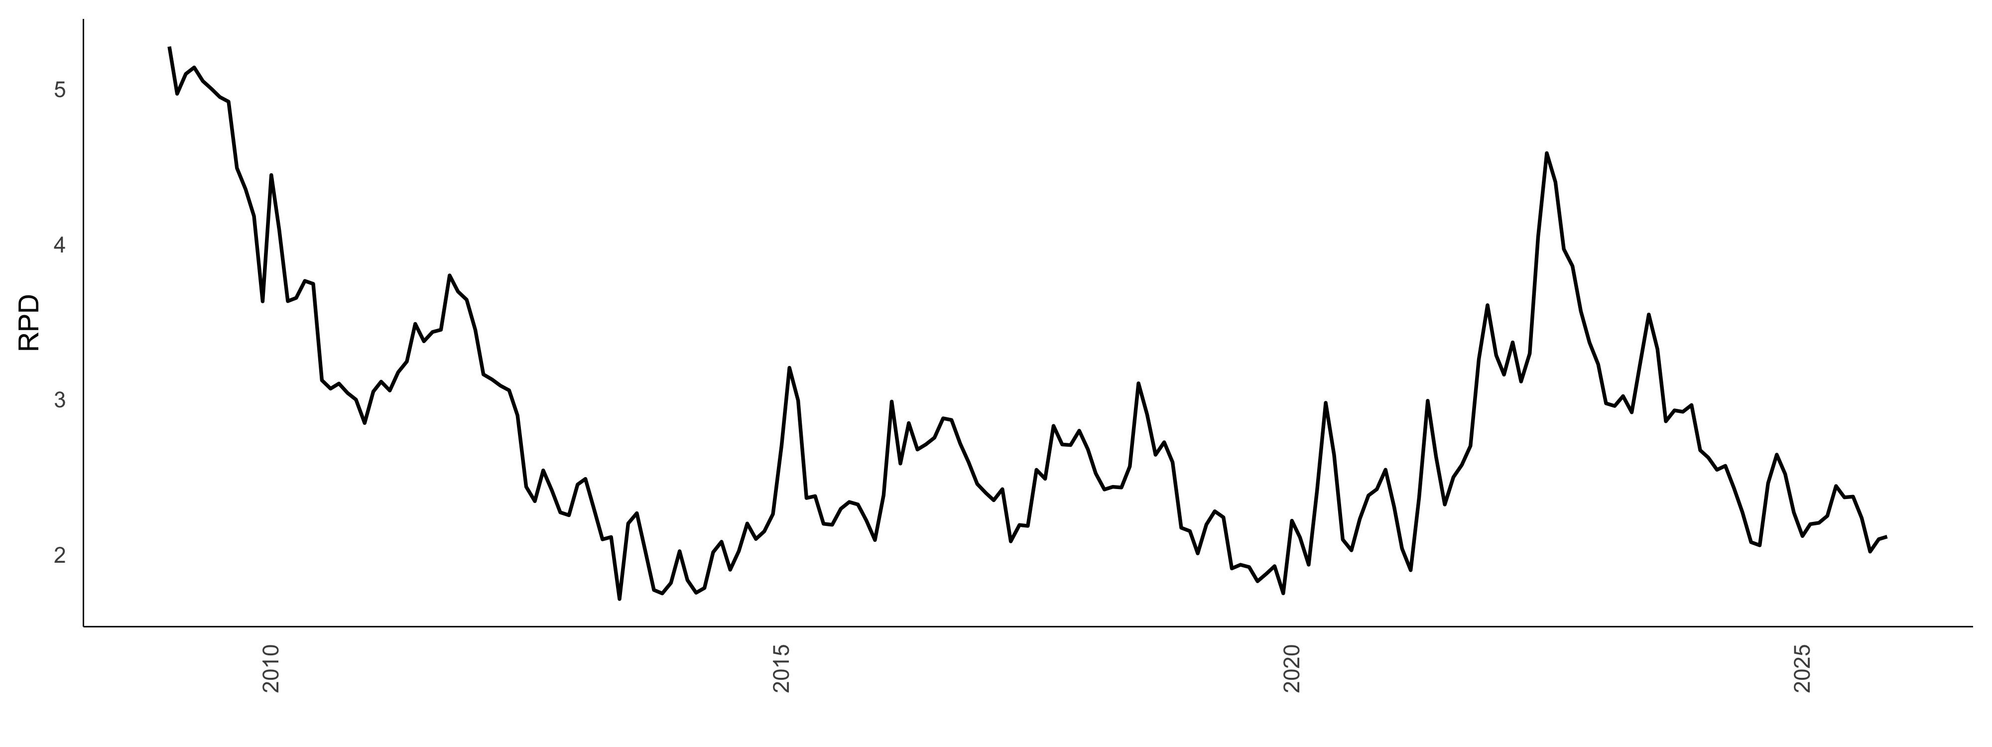
Figure 1: RPD over-time
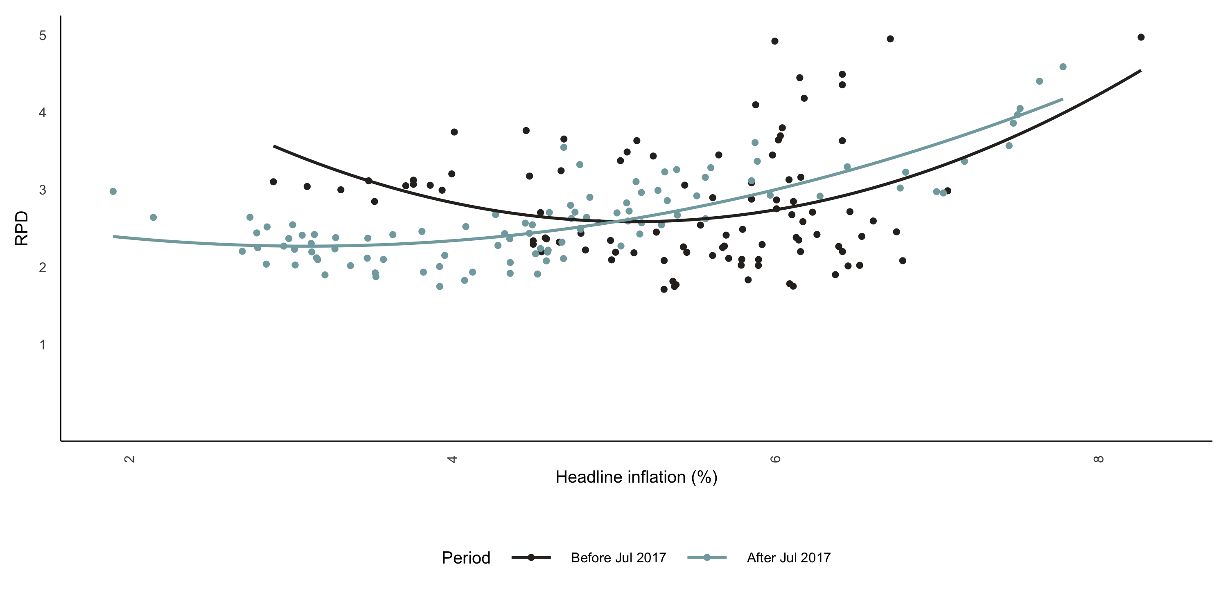
Figure 2: RPD vs Headline Inflation. Note: A quadratic polynomial was fitted on two the data before and after July 2017. This is the period of the first inflation target reform to a mid-point of 4.5 per cent.

The formal estimation in Table 1, using ordinary least squares of both the linear and quadratic specifications, reveals that indeed the evidence for non-linearity is stronger. All the estimates of the quadratic term ($π^{2}$) are all significant. As noted in the methodology section, this significant is in the presence of estimated breakpoints in the inflation data. Therefore, the next question is wether the estimates of the RPD are stable overtime, or are subject to significant shocks?
Table 1: Baseline regressions
 | Full Sample | Pre 2017 | Post 2017 | Full Sample: Squared Inflation | Pre 2017: Squared Inflation | Post 2017: Squared Inflation
$$π_{t}$$ | 0.01* | 0.009 | 0.032*** | -0.046 | -0.104 | -0.033
$$π_{t}^{2}$$ |  |  |  | 0.006* | 0.011* | 0.007*
$$RPD_{t-3}$$ | 0.244*** | 0.173* | 0.248** | 0.234*** | 0.154 | 0.209**
$$RPD_{t-2}$$ | -0.382*** | -0.14 | -0.645*** | -0.363*** | -0.111 | -0.609***
$$RPD_{t-1}$$ | 1.039*** | 0.896*** | 1.116*** | 1.017*** | 0.864*** | 1.063***
$$D_{2022m8}$$ | 0.026 |  | 0.024 | -0.001 |  | -0.012
$$D_{2020m2}$$ | -0.116 |  | -0.213** | -0.106 |  | -0.205**
$$D_{2017m7}$$ | 0.156* |  |  | 0.161*
$$D_{2014m7}$$ | -0.098 | -0.087 |  | -0.105 | -0.096
$$D_{2011m12}$$ | 0.042 | 0.027 |  | 0.047 | 0.037
$$C$$ | 0.044 | 0.012 | 0.117*** | 0.184** | 0.326* | 0.304**
Note: *** = p value < 0.01, ** = 0.01 < p value < 0.05, * = 0.05 < p value < 0.1.

In Figure 3 and Figure 4 we estimate the rolling and recursive estimates. 24- and 60-month windows are implemented for the rolling window estimation. The results of both methods suggest a dynamic relationship with periods of strong significance. In the main, we observe a positive response of RPD to a 1 percentage point change in headline inflation. This dynamic relationship further builds the case for a U-shaped relationship.
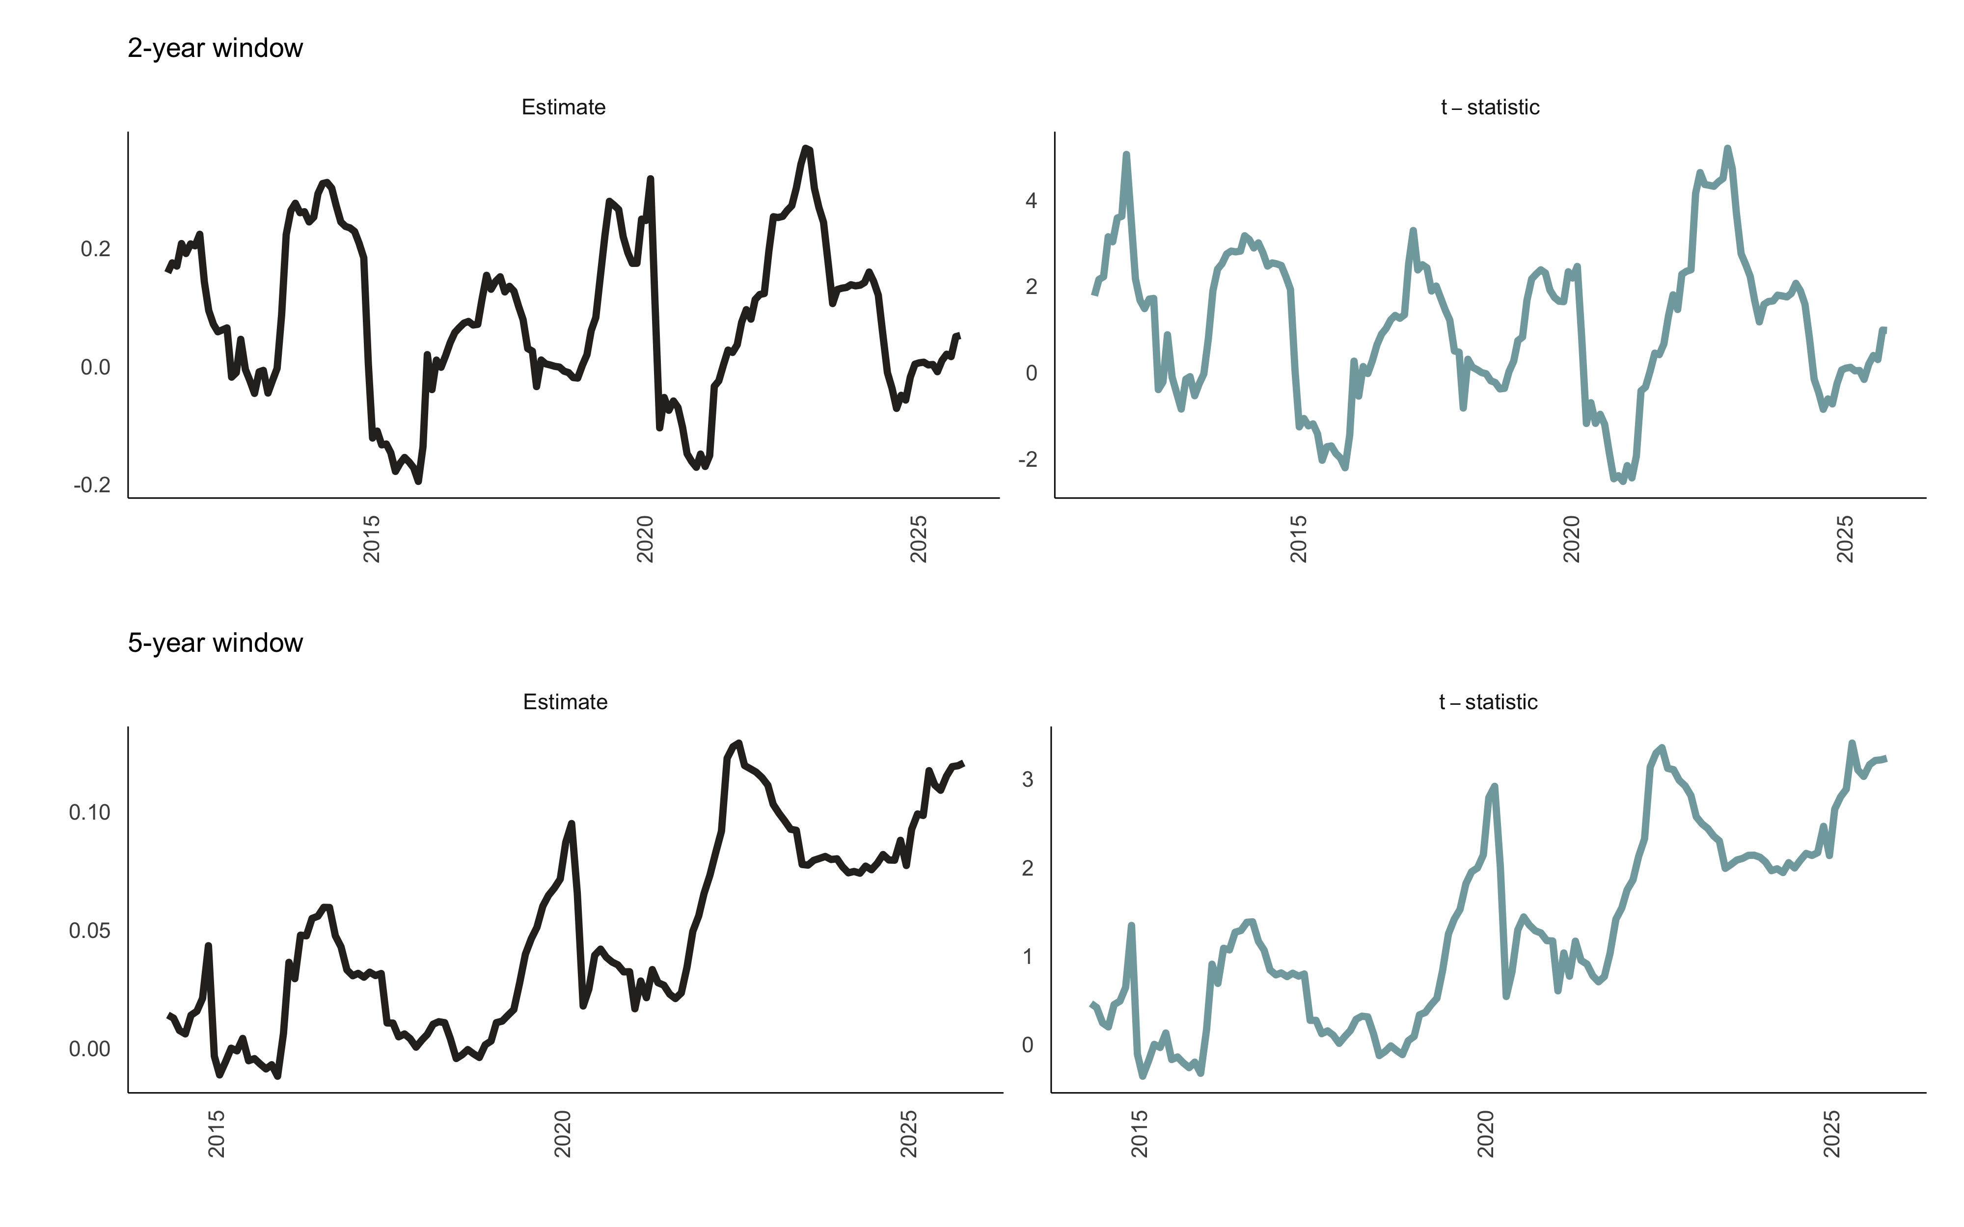
Figure 3: Rolling regressions. Note: t-statistics of greater (or less) than 1.96 (or -1.96) is significant at a 5% level of significance.
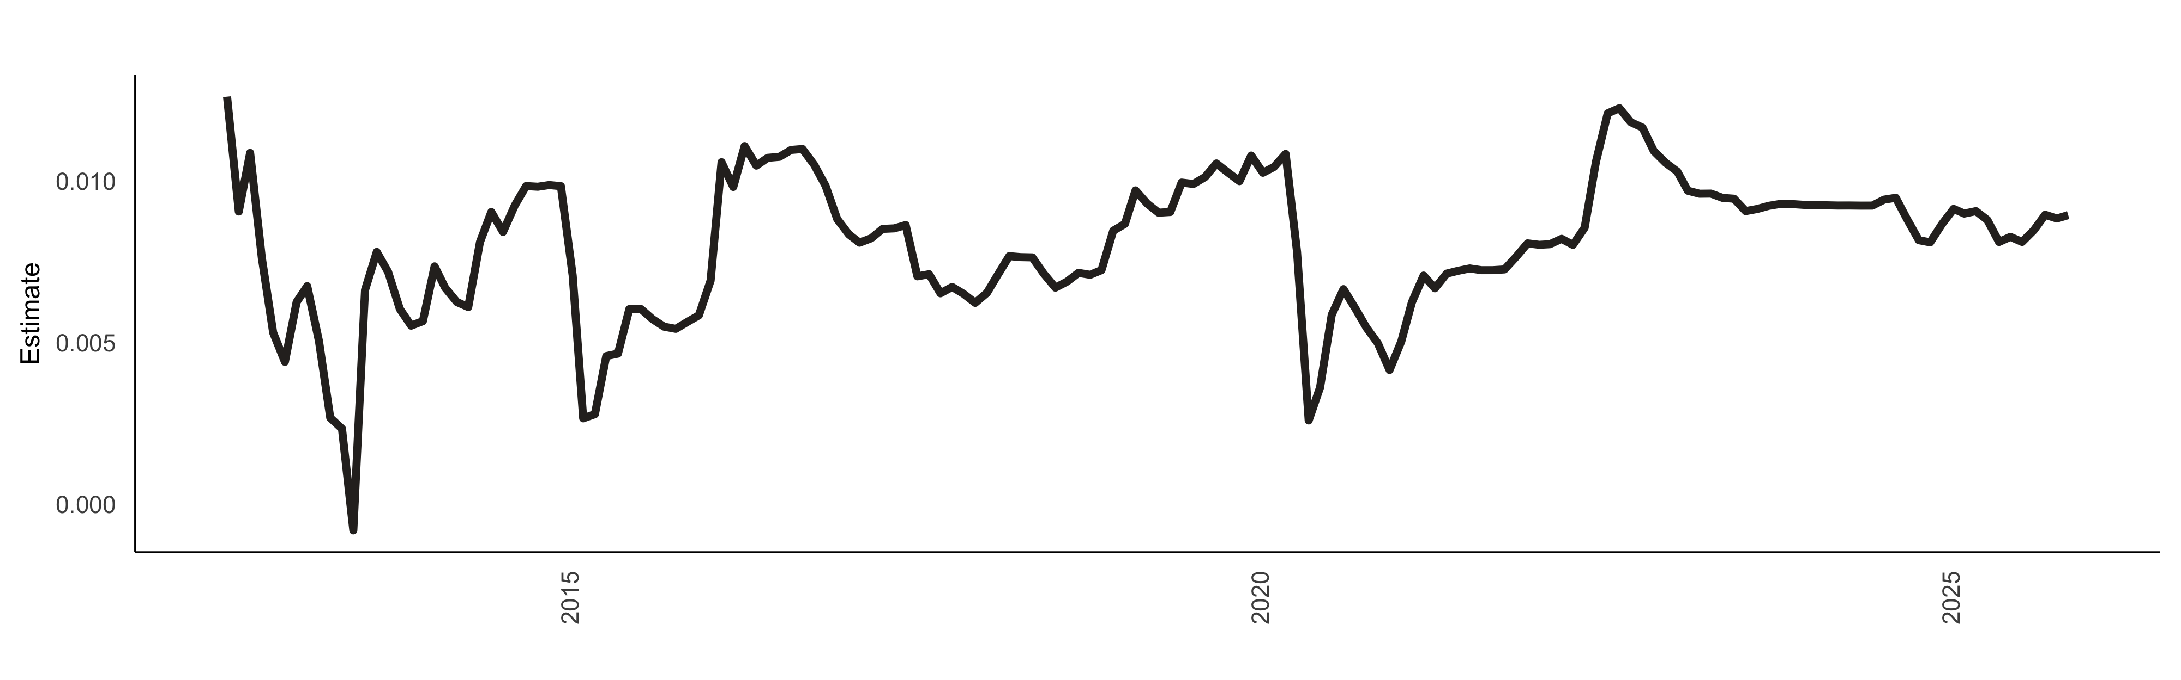
Figure 4: Recursive regressions. Note: Recursive regression estimates of the coefficient on absolute headline inflation with a fixed start date of 2012-07.

Figure 5 shows the estimated nonparametric conditional mean effect of inflation on RPD for the full sample, pre-2017 and post-2017 samples. The optimal bandwidth was selected automatically using cross-validation method. To test the sensitivity of the nonparametric estimates to the smoothing parameter, we also consider smaller and larger bandwidths in both Figure 5 and Figure 6, in both cases the results are qualitatively similar indicating that the nonparametric estimates are robust to the smoothing parameter. In Figure 5 across all samples, the relationship is approximately linear and upward sloping indicating that the marginal effect is positive across the inflation range, broadly in line with the menu cost theoretical predictions.
Specifically, in the full sample, Figure 5 shows that there are small positive effects on RPD for the inflation range of 2-3 per cent, with RPD at its lowest in this inflation range indicative of the optimal inflation range as RPD is not amplified, otherwise RPD increases monotonically as inflation increases beyond this range. Thus, higher average inflation increases price misconception, leading to inefficient resource allocation across firms equivalent to a negative productivity shock (Damjanovic and Nolan 2010). The pre-2017 sample results show a similar profile except that a 3 per cent inflation rate minimises price dispersion. These findings are similar across both the Guassian and Epanechnikov kernels.
Interestingly, the sub-samples results show regime shifts in the inflation and RPD relationship. The post-2017 sub-sample still shows positive and linear effects however the curvature is weaker and flatter in contrast to the post-2017 period, suggesting regime-dependence (Choi, Kim, and O’Sullivan 2011; Baglan, Yazgan, and Yilmazkuday 2016; Hornstein, Ruge-Murcia, and Wolman 2024). Specifically, relatively lower regimes levels are associated with weaker inflation effects on RPD because even at high inflation rates in the range of 7-8 per cent the curve is less steep than the pre-2017 results - suggesting a less responsiveness of RPD. The results in Figure 5 indicate that the optimal inflation rate in the post-2017 sub-sample is also in the range of 2-3 per cent. These optimal inflation rate estimates are lower than the 4 per cent estimate from (Caraballo and Dabús 2013) whom we closely follow in our empirical framework, but our results are closer to estimates near in the literature. See Diercks (2019) for a summary of these studies.
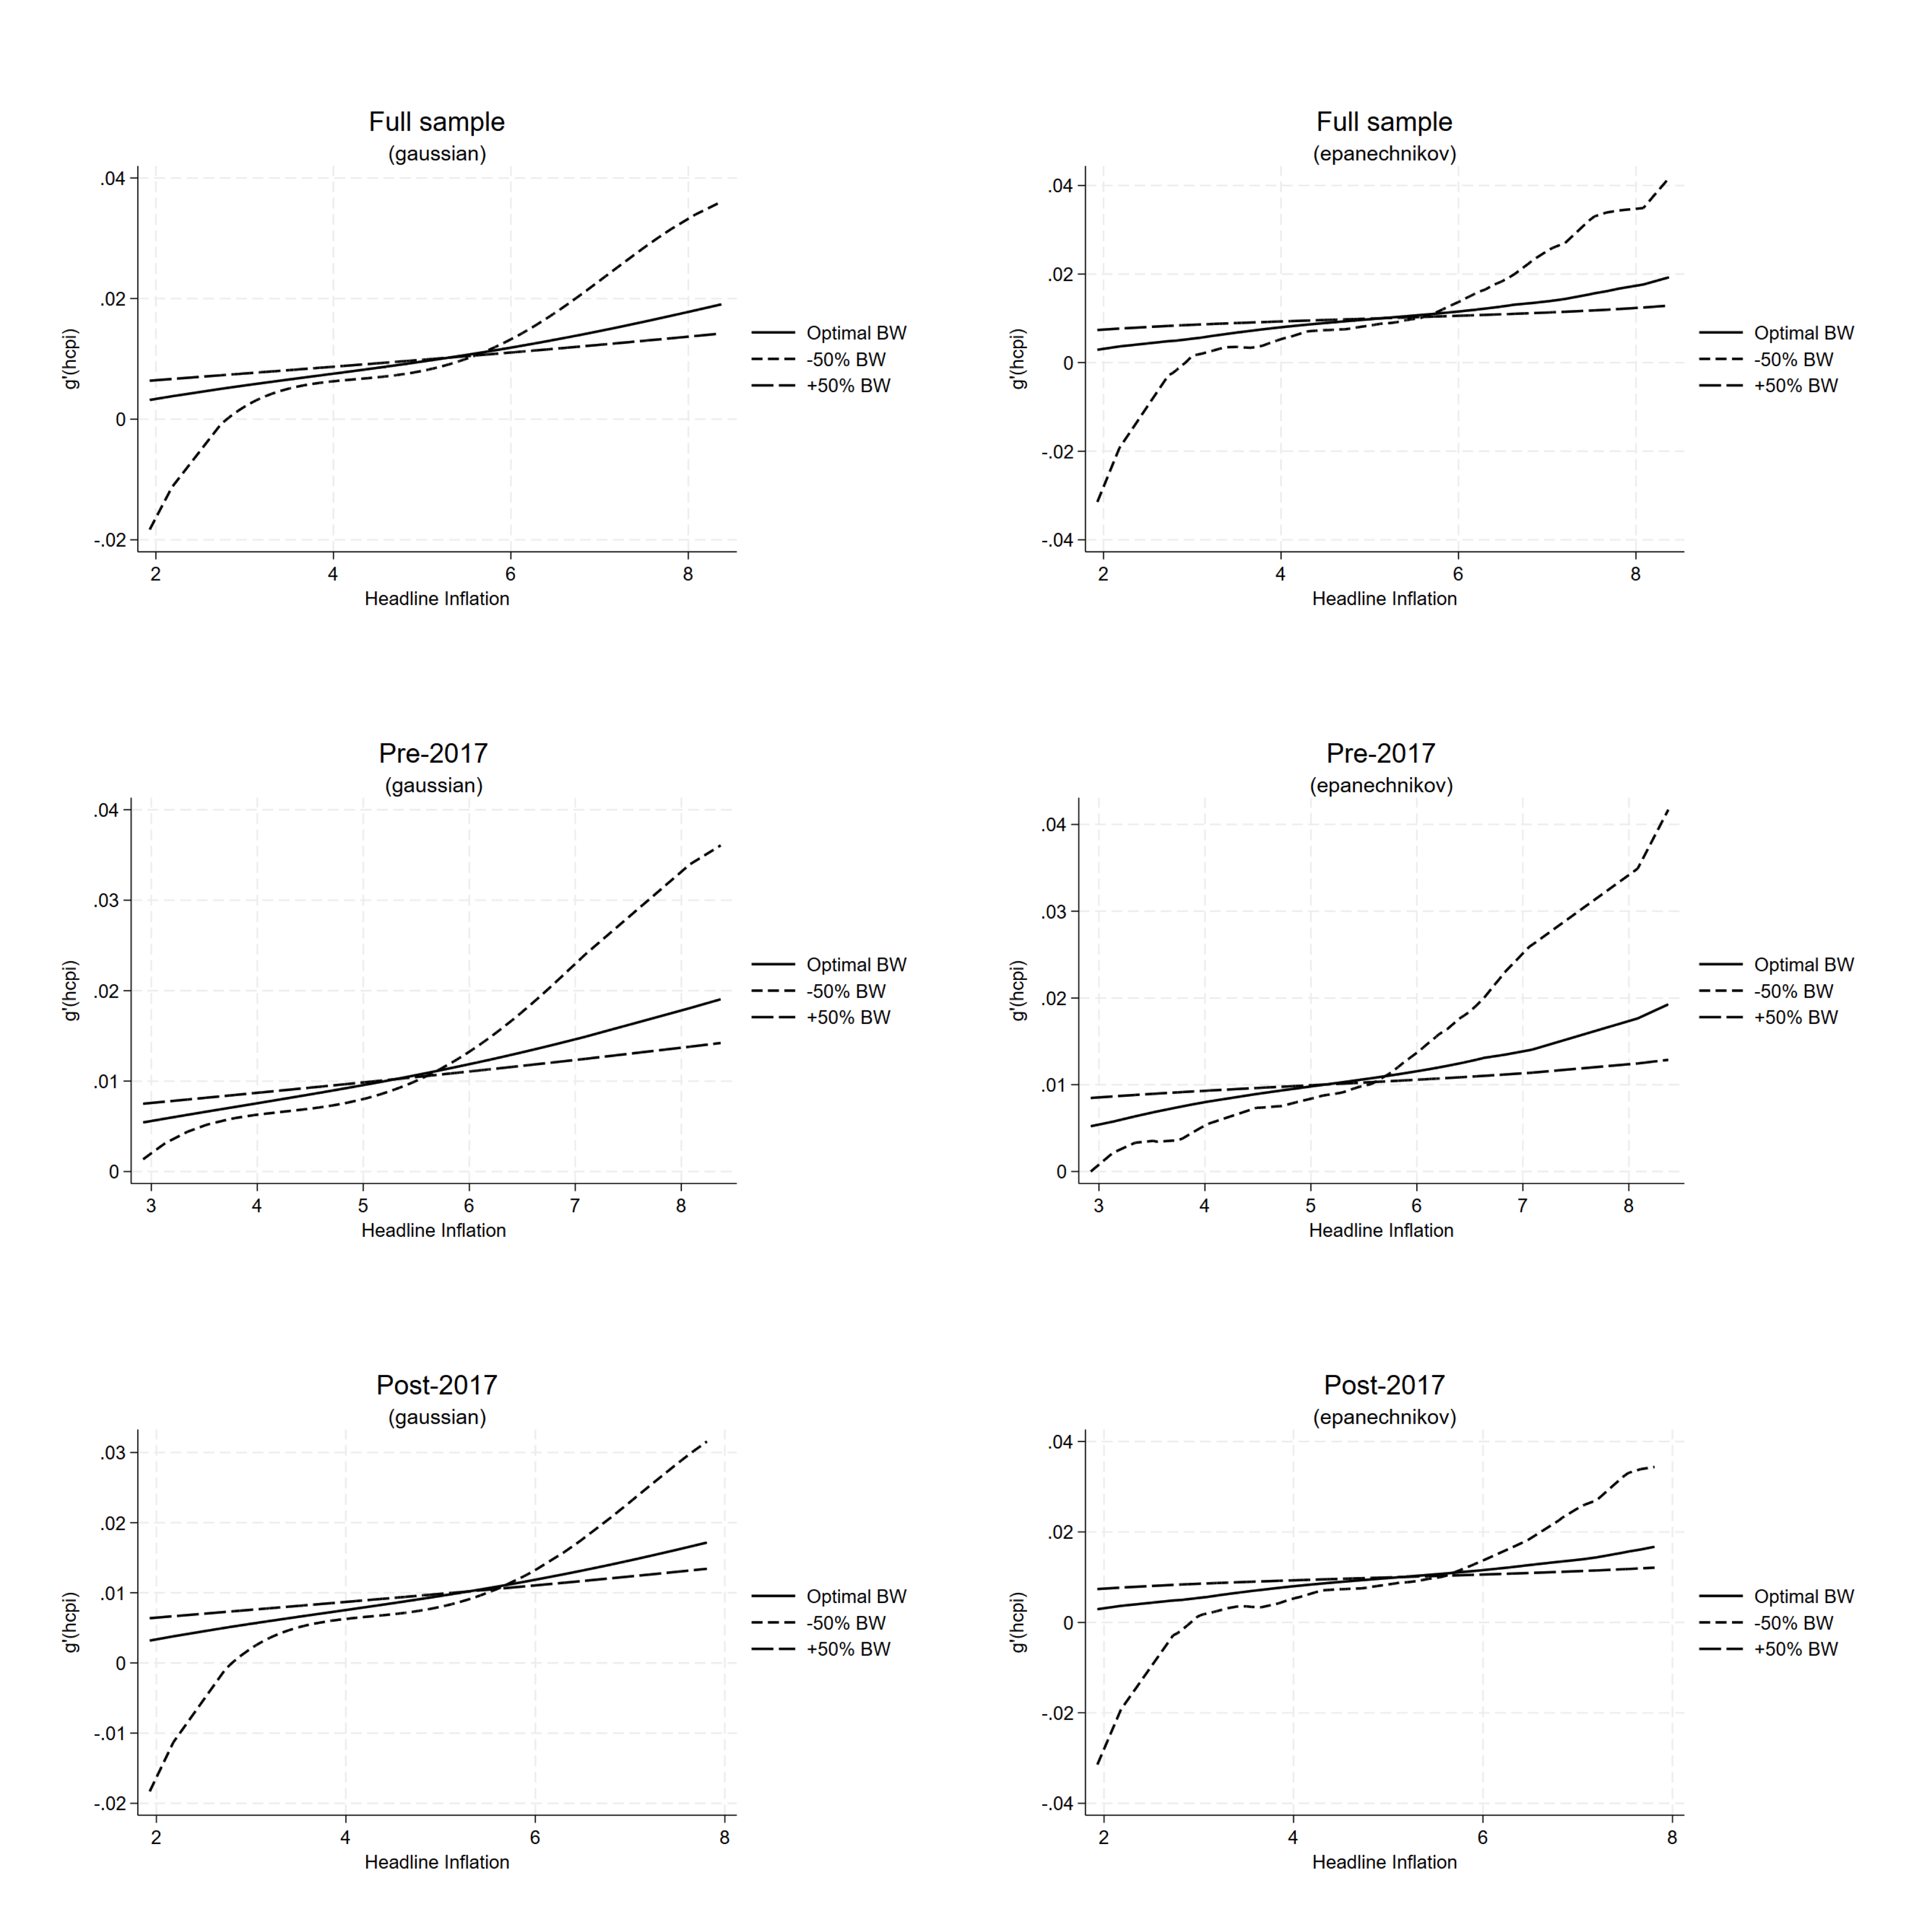
Figure 5: Semi-parametric regressions for headline inflation. Note: hcpi is headline inflation. This figure shows the estimated nonparametric conditional mean effect of headline inflation on RPD for the full sample, pre-2017 and post-2017 samples. The optimal bandwidth was selected automatically using cross-validation method.

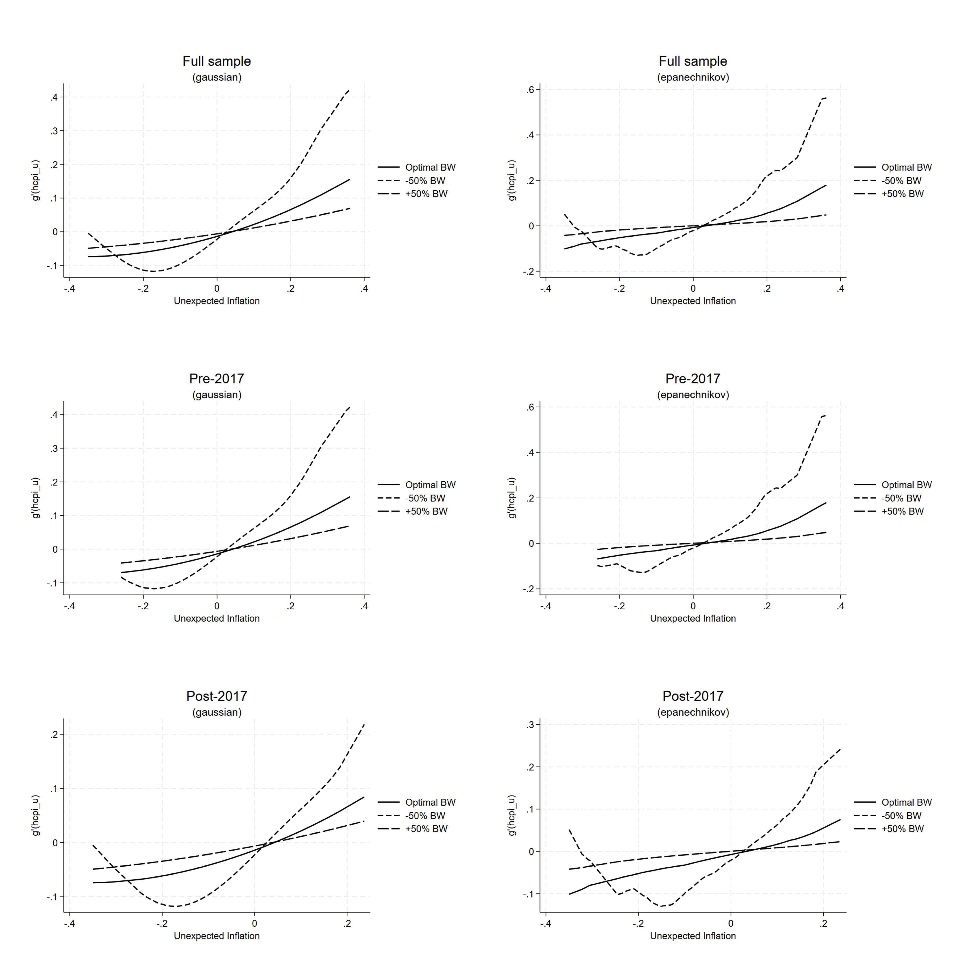
Figure 6: Semi-parametric regressions for unexpected inflation. Note: hcpi_u is the unexpected component of headline inflation. This figure shows the estimated nonparametric conditional mean effect of unexpected inflation on RPD for the full sample, pre-2017 and post-2017 samples. The optimal bandwidth was selected automatically using cross-validation method.
Figure 6 shows the estimated results of the nonparametric effect of unexpected inflation on RPD, and the findings are broadly consistent with the predictions of the signal extraction theory. These results show exhibit U-shaped profile where however the effects of positive and negative surprises are asymmetric. Positive inflation surprises generate a stronger dispersion response than negative ones.
Notably, the estimated effects are similar in both the full sample and the pre-2017 sample periods. The response of RPD to negative inflation surprises is relatively moderate and relatively flat, while positive inflation causes RPD to accelerate more noticeably particularly for inflation surprises near 0.2 and above. This suggests that price-setters respond more aggressively to inflationary surprises than deflationary ones suggesting that positive inflation surprises create informational noise and as a result firms confuse aggregate price shocks with relative shocks leading to higher relative price variability consistent with the misconception models. However, unlike these theoretical predictions as well as the empirical studies (Caraballo and Dabús 2013; Becker and Nautz 2012; Sara-Zaror 2024) the positive and negative inflation shocks, in our case, do not have a symmetric effect on RPD. The post-2017 suggests a structural regime change in the relationship as the magnitude of the effect of unexpected inflation on RPD is weaker on either side of the distribution. We attribute this to a relatively low inflation regime as well as better anchored inflation expectations (Du Rand, Hollander, and Van Lill 2023) in the post-2017 period in line with the adoption of a lower inflation target in both 2017 as well as 2025. For example, the x-axis only extends to about ±0.25 percentage points in the post-2017 sample, reflecting less variation in unexpected inflation compared to the pre-2017 sample. Furthermore, the latter years in our sample are characterised by significant global shocks to inflation from the COVID-2019 Pandemic in 2020, the post-pandemic recovery induced energy price shock in 2021 as well as the global food price shock after the outbreak of the Russia-Ukraine war in 2022. These global shocks would’ve induced a similar price setting behavioural response by firms in the same direction therefore compressing price dispersion (Nakamura et al. 2018) which, in our view, also explains the relatively benign post-2017 results.

Robustness
To further investigate the idea of RPD-inflation regimes, we take a novel approach in the literature to estimate a quantile-on-quantile (QQR) regression analysis (Koenker 2017). The QQR will further examine the inflation-RPD nexus since kernel estimation in Figure 5 and Figure 6 show average marginal effects across the inflation distribution, while the QQR directly estimates the dependence structure across the joint distribution of inflation ($τ$) and RPD ($θ$). The results in Figure 7 show that, across the all-sub samples, in most quantiles of RPD, higher quantiles of inflation are associated with a positive and increasingly strong effect on RPD. When inflation is in its upper quantiles ($τ→1$), the coefficient is at its largest and most positive, suggesting a strong amplification where high inflation episodes are associated with meaningfully larger relative price dispersion. At low quantiles of inflation ($τ←0$), the relationship is substantially muted and largely statistically insignificant (white areas), particularly for middle quantiles of RPD indicating that low or stable inflation has little systematic effect on relative price dispersion. This is a double confirmation of the non-linear relationship. Furthermore, lower quantiles of RPD ($θ<0.25$) show weak effects throughout, implying that episodes of low-price dispersion are relatively insensitive to inflation regardless of where inflation sits in its distribution.
Notably in the post-2017 sub-sample, structural changes in the relationship are evident. Firstly, the size of the magnitude is larger, and the positive effects are concentrated at very high inflation quantiles likely reflecting the heightened inflationary volatility of the post-2017 period, including commodity price shocks and the COVID-19 era inflation surge. Secondly, there is a wider region of insignificance at low and mid inflation quantiles ($τ<0.50$) particularly for lower quantiles of RPD implying low-to-moderate inflation in the post-2017, associated with reductions in the inflation target, has little systematic effect on price dispersion. The relationship being driven almost entirely by tail inflation events or shocks.
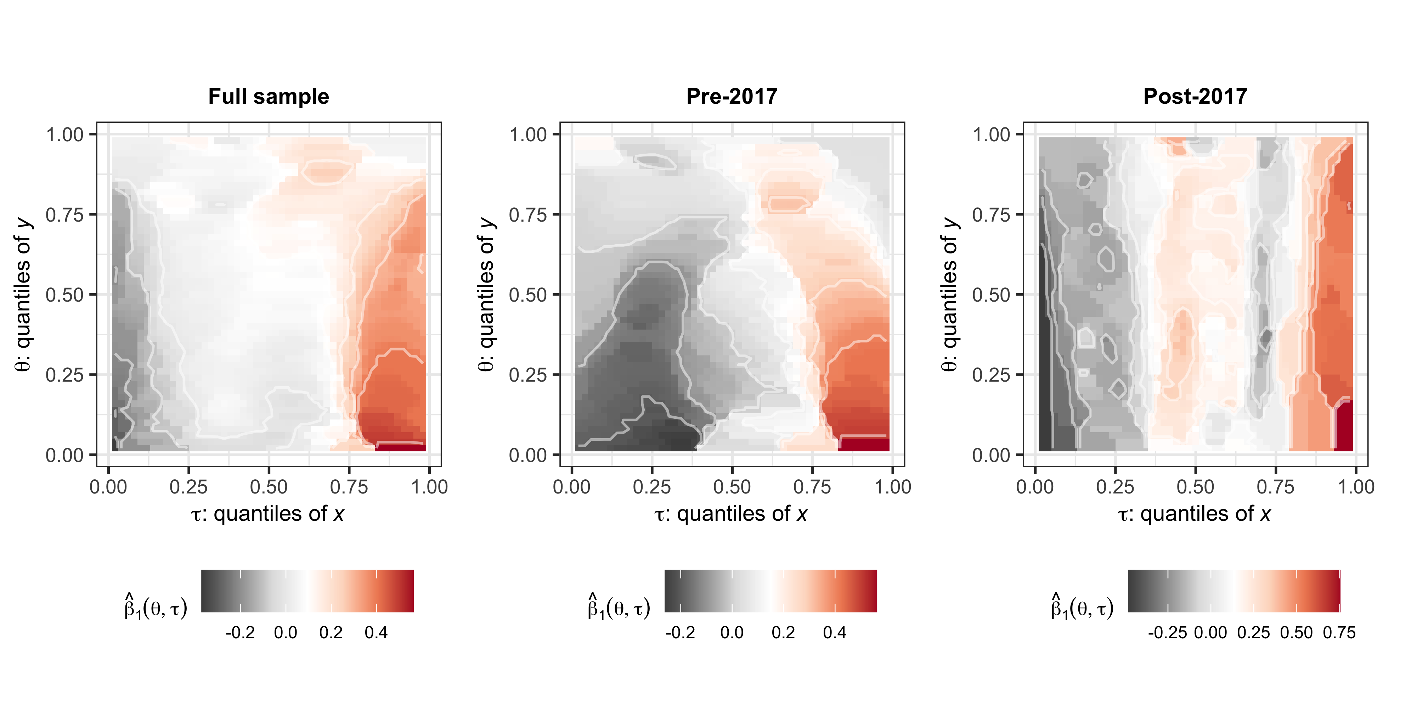
Figure 7: Quantile on quantile regressions for headline inflation. Note: In the quantile-on-quantile regression plots, the x-axis represents the quantiles of headline inflation, while the y-axis represents the quantiles of RPD. The colour gradient indicates the strength and direction of the relationship between headline inflation and RPD across different quantiles. Warmer colours (e.g., red) indicate a stronger positive relationship, while cooler colours (e.g., grey) indicate a stronger negative relationship. The white areas represent quantiles where the relationship is not statistically significant.
Interestingly, the positive coefficient region in Figure 8 is larger and more pervasive across the space compared to Figure 7 with the implication that unexpected inflation appears to have a stronger and more broadly distributed positive effect on relative price dispersion than aggregate inflation. Specially, positive inflation surprises have a visible effect on RPD even at moderate quantiles in the pre-2017 era. This implies that even modest positive inflation surprises - not just extreme ones - were sufficient to generate significant RPD responses before 2017 and in the lower quantiles of RPD ($θ<0.25$), the effects remain largely insignificant. Interestingly, there is a weak negative region at very low quantiles of unexpected inflation for mid-range RPD, suggesting that negative inflation surprises were mildly associated with reduced dispersion in this era.
Positive inflation surprises have less concentrated effects in the post-2017 sub-sample compared to the pre-2017 period and notably the coefficient scale is wider compared to pre-2017 indicating higher sensitivity of RPD to unexpected inflation as inflation shocks surged enormously after 2017 and these shocks. There is a broader insignificance at intermediate quantile combinations. A notable feature of the post-2017 sub-sample is the emergence of statistically significant negative coefficients at low quantiles of unexpected inflation ($τ<0.25$), particularly across mid-to-high quantiles of RPD ($θ>0.25$). This means negative inflation surprises in the post-2017 period, were associated with lower RPD. This pattern was absent (or negligible) pre-2017. We attribute this to the likelihood that when inflation expectations were managed down by the central bank as inflation targets are lowered, downside inflation surprises actively compress price dispersion, while upside surprises amplify it (Bems et al. 2021; Moessner and Takáts 2020).
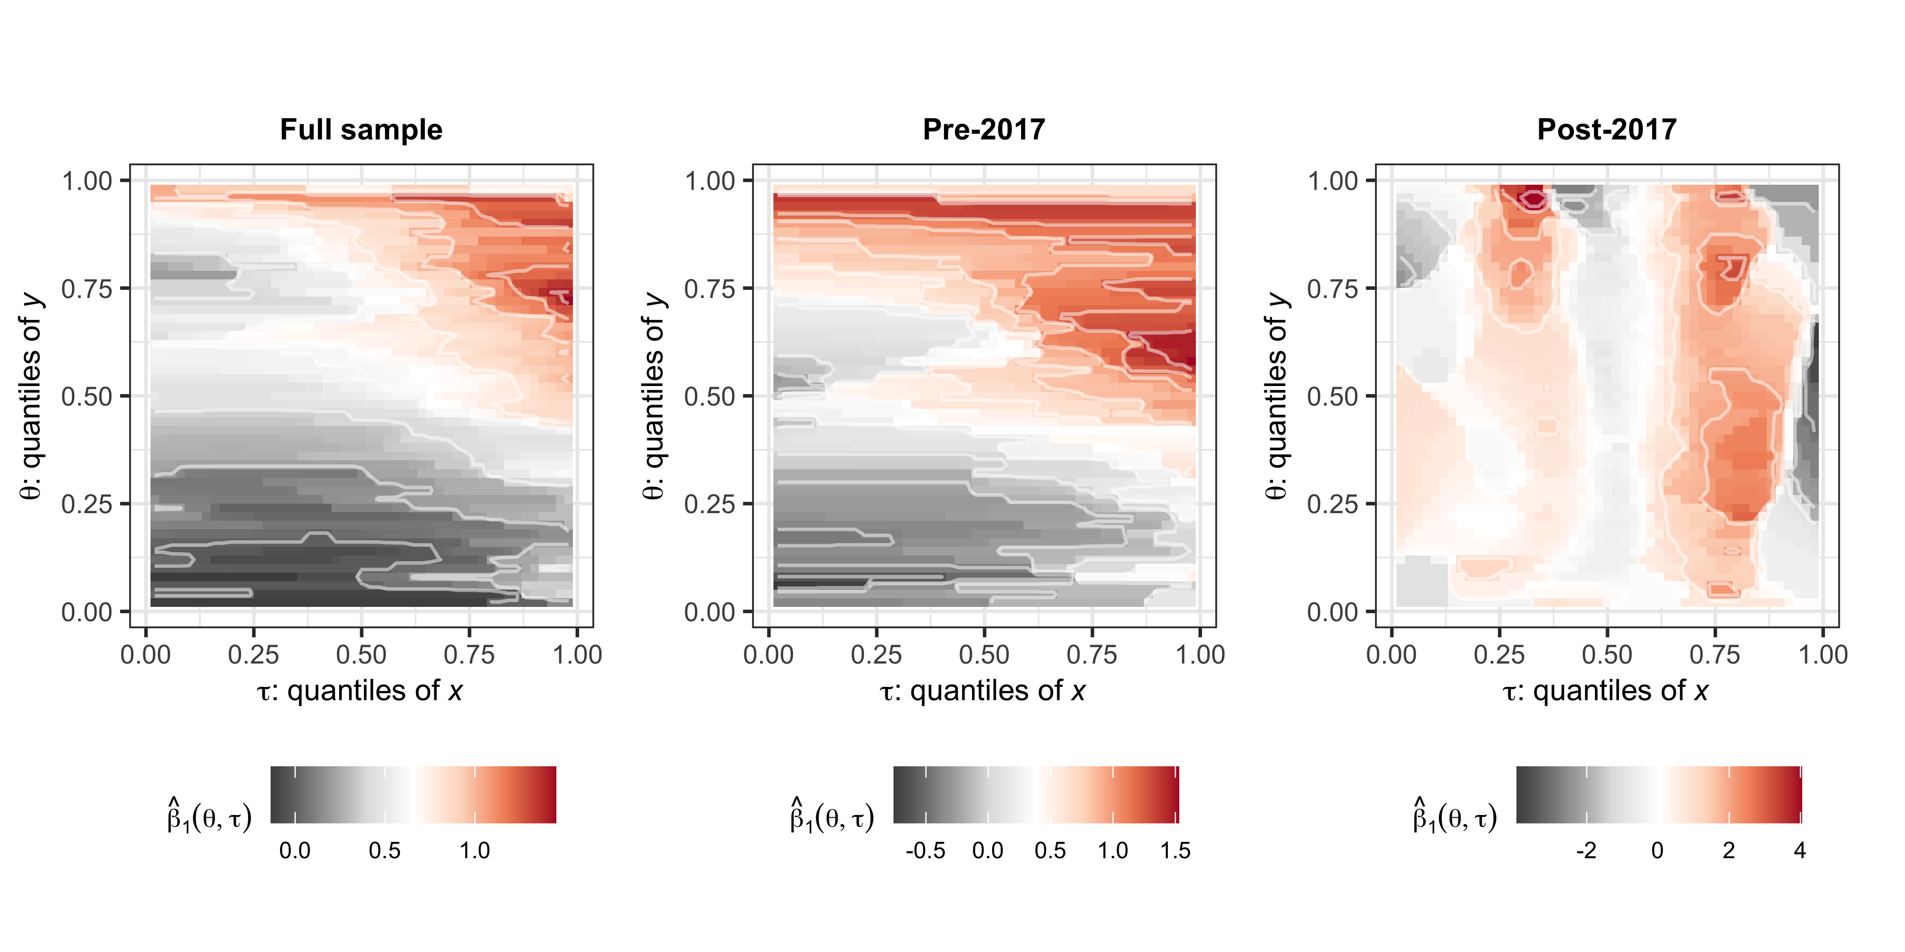
Figure 8: Quantile on quantile regressions for the unexpected component of inflation. Note: The x-axis represents the quantiles of the unexpected component of headline inflation, while the y-axis represents the quantiles of RPD.

Conclusion
This paper provides a comprehensive empirical analysis of the relationship between inflation and relative price dispersion (RPD) in South Africa, highlighting the importance of structural changes in inflation targeting on this nexus. Our findings support the presence of a nonlinear and dynamic relationship between inflation and RPD, consistent with the signal extraction and monetary search models that allow for a non-zero optimal inflation rate. The semi-parametric estimation revealed that average inflation effects on price dispersion evolve over time, especially around changes in inflation targets nevertheless lower inflation is favourable for RPD, while the quantile-on-quantile regression uncovered heterogeneity in the impact of inflation across different parts of the RPD distribution. This dynamic behaviour reinforces the idea that lower inflation reduces welfare losses associated with price rigidities and informational frictions. Interestingly, testing the predictions of the signal extraction models, inflation surprises in our case do not have a symmetric effect on price relative variability instead of only positive surprises worsen price variability or RPD
The post-2017 period is characterized by a unique combination of factors including revised lower inflation target, and significant global shocks such as the COVID-19 pandemic, supply chain disruptions, energy price shocks, and the Russia-Ukraine conflict. These elements contributed to synchronized price adjustments across firms, compressing relative price dispersion. Our results suggest that the inflation-RPD trade-off will move towards a more favourable profile compared to the pre-2017 era as prices are anchored at the recently adopted 3 per cent inflation target.
This analysis contributes to the relatively sparse literature on emerging markets by providing nuanced insights into how inflation influences relative price variability under evolving monetary policy frameworks. Moreover, our findings are supportive of the decision to lower South Africa’s inflation target in 2025. The South African experience—moving from broad inflation bands to more precise target midpoints demonstrates the complex interplay between inflation regimes and price adjustments. Policymakers targeting lower inflation in similar emerging economies should consider these nonlinear dynamics and transitional effects to strike a balance between inflation control and minimizing distortions in relative prices that can hinder efficient resource allocation and economic growth. Ultimately, our results advocate for flexible inflation targets that account for structural features of the economy and the benefits of low inflation in optimizing welfare.

References
Baglan, Deniz, M. Ege Yazgan, and Hakan Yilmazkuday. 2016. “Relative Price Variability and Inflation: New Evidence.” Journal of Macroeconomics 48: 263–82.
Bai, Jushan, and Pierre Perron. 1998. “Estimating and Testing Linear Models with Multiple Structural Changes.” Econometrica, 47–78. https://www.jstor.org/stable/2998540.
Barro, Robert J. 1976. “Rational Expectations and the Role of Monetary Policy.” Journal of Monetary Economics 2 (1): 1–32.
Becker, Sascha S., and Dieter Nautz. 2012. “Inflation, Price Dispersion and Market Integration Through the Lens of a Monetary Search Model.” European Economic Review 56 (3): 624–34.
Bems, Rudolfs, Francesca Caselli, Francesco Grigoli, and Bertrand Gruss. 2021. “Expectations’ Anchoring and Inflation Persistence.” Journal of International Economics 132: 103516.
Benabou, Roland. 1992. “Inflation and Efficiency in Search Markets.” The Review of Economic Studies 59 (2): 299–329.
Caglayan, Mustafa, and Alpay Filiztekin. 2003. “Nonlinear Impact of Inflation on Relative Price Variability.” Economics Letters 79 (2): 213–18.
Caraballo, Ma Ángeles, and Carlos Dabús. 2013. “Price Dispersion and Optimal Inflation: The Spanish Case.” Journal of Applied Economics 16 (1): 49–70. https://doi.org/10.1016/S1514-0326(13)60003-3.
Chang, Bisharat Hussain, Arshian Sharif, Ameenullah Aman, Norazah Mohd Suki, Asma Salman, and Syed Abdul Rehman Khan. 2020. “The Asymmetric Effects of Oil Price on Sectoral Islamic Stocks: New Evidence from Quantile-on-Quantile Regression Approach.” Resources Policy 65: 101571.
Choi, Chi-Young. 2010. “Reconsidering the Relationship Between Inflation and Relative Price Variability.” Journal of Money, Credit and Banking 42 (5): 769–98. https://doi.org/10.1111/j.1538-4616.2010.00307.x.
Choi, Chi-Young, Young Se Kim, and Róisín O’Sullivan. 2011. “Inflation Targeting and Relative Price Variability: What Difference Does Inflation Targeting Make?” Southern Economic Journal 77 (4): 934–57. https://doi.org/10.4284/0038-4038-77.4.934.
Cukierman, Alex. 1983. “Relative Price Variability and Inflation: A Survey and Further Results.” In Carnegie-Rochester Conference Series on Public Policy, 19:103–57. Elsevier.
Damjanovic, Tatiana, and Charles Nolan. 2010. “Relative Price Distortions and Inflation Persistence.” The Economic Journal 120 (547): 1080–99.
Diercks, Anthony M. 2019. “The Reader’s Guide to Optimal Monetary Policy.” Available at SSRN 2989237.
Du Rand, Gideon, Hylton Hollander, and Dawie Van Lill. 2023. A Deep Learning Approach to Estimation of the Phillips Curve in South Africa. 2023/79. WIDER Working Paper.
Fielding, David, and Paul Mizen. 2000. “Relative Price Variability and Inflation in Europe.” Economica 67 (265): 57–78. https://doi.org/10.1111/1468-0335.00195.
Gupta, Rangan, Christian Pierdzioch, Refek Selmi, and Mark E. Wohar. 2018. “Does Partisan Conflict Predict a Reduction in US Stock Market (Realized) Volatility? Evidence from a Quantile-on-Quantile Regression Model.” The North American Journal of Economics and Finance 43: 87–96.
Head, Allen, and Alok Kumar. 2005. “Price Dispersion, Inflation, and Welfare.” International Economic Review 46 (2): 533–72. https://doi.org/10.1111/j.1468-2354.2005.00333.x.
Hercowitz, Zvi. 1981. “Money and the Dispersion of Relative Prices.” Journal of Political Economy 89 (2): 328–56. https://doi.org/10.1086/260968.
Hornstein, Andreas, Francisco J. Ruge-Murcia, and Alexander L. Wolman. 2024. “The Relationship Between Inflation and the Distribution of Relative Price Changes.”
Koenker, Roger. 2017. “Quantile Regression: 40 Years On.” Annual Review of Economics 9 (1): 155–76. https://doi.org/10.1146/annurev-economics-063016-103651.
Koenker, Roger, and Gilbert Bassett Jr. 1978. “Regression Quantiles.” Econometrica: Journal of the Econometric Society, 33–50. https://www.jstor.org/stable/1913643.
Lach, Saul, and Daniel Tsiddon. 1992. “The Behavior of Prices and Inflation: An Empirical Analysis of Disaggregated Price Data.” Journal of Political Economy 100 (2): 349–89. https://doi.org/10.1086/261821.
Lucas, Robert E. 1973. “Some International Evidence on Output-Inflation Tradeoffs.” The American Economic Review 63 (3): 326–34. https://www.jstor.org/stable/1914364.
Mishra, Shekhar, Arshian Sharif, Sashikanta Khuntia, Muhammad Saeed Meo, and Syed Abdul Rehman Khan. 2019. “Does Oil Prices Impede Islamic Stock Indices? Fresh Insights from Wavelet-Based Quantile-on-Quantile Approach.” Resources Policy 62: 292–304.
Moessner, Richhild, and El\Hod Takáts. 2020. “How Well-Anchored Are Long-Term Inflation Expectations?”
Nakamura, Emi, Jón Steinsson, Patrick Sun, and Daniel Villar. 2018. “The Elusive Costs of Inflation: Price Dispersion During the US Great Inflation.” The Quarterly Journal of Economics 133 (4): 1933–80.
Ndou, Eliphas, and Nombulelo Gumata. 2017. Inflation Dynamics in South Africa: The Role of Thresholds, Exchange Rate Pass-Through and Inflation Expectations on Policy Trade-Offs. Springer.
Ndou, Eliphas, and Siobhan Redford. 2014. “Relative Price Variability: Which Components of the Consumer Price Index Contribute Towards Its Variability?” South African Reserve Bank Working Paper Series.
Robinson, Peter M. 1988. “Root-N-consistent Semiparametric Regression.” Econometrica: Journal of the Econometric Society, 931–54. https://www.jstor.org/stable/1912705.
Rotemberg, Julio J. 1983. “Aggregate Consequences of Fixed Costs of Price Adjustment.” The American Economic Review 73 (3): 433–36. https://www.jstor.org/stable/1808128.
Sara-Zaror, Francisca. 2024. “Inflation, Price Dispersion, and Welfare: The Role of Consumer Search.” Available at SSRN 4127502.
Sheshinski, Eytan, and Yoram Weiss. 1979. “Demand for Fixed Factors, Inflation and Adjustment Costs.” The Review of Economic Studies 46 (1): 31–45.
———. 1983. “Optimum Pricing Policy Under Stochastic Inflation.” The Review of Economic Studies 50 (3): 513–29.
Sim, Nicholas. 2016. “Modelling the Dependence Structures of Financial Assets Through the Copula Quantile-on-Quantile Approach.” International Review of Financial Analysis 48: 31–45.

Appendix: Data and descriptive statistics

Data
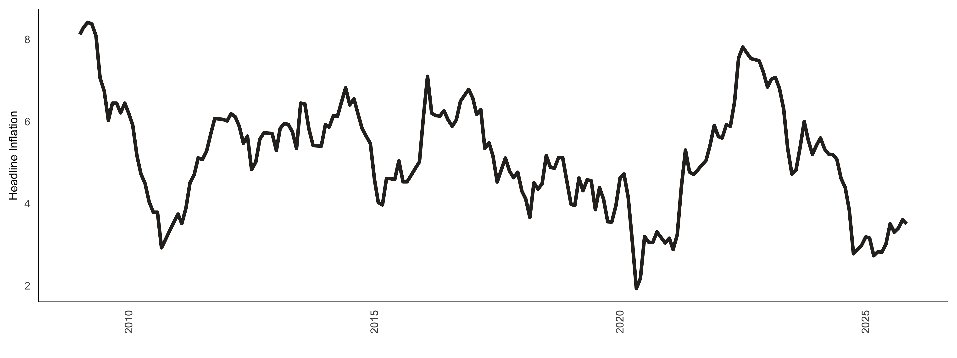
Figure 9: Headline inflation (%).
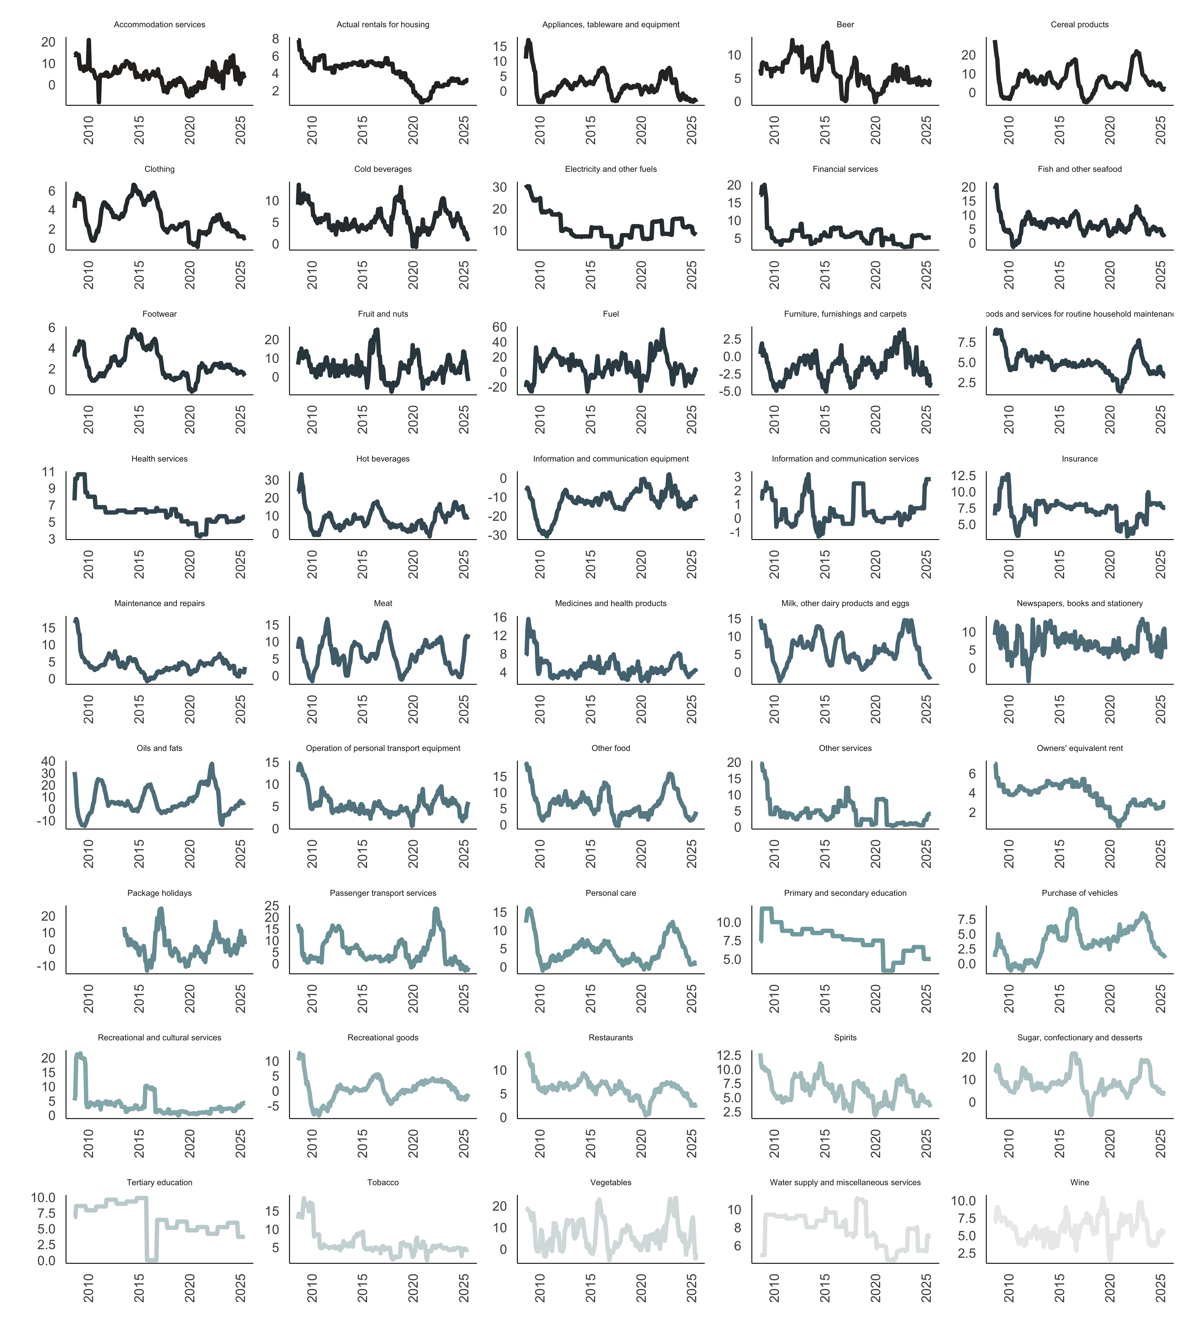
Figure 10: Inflation categories (%)
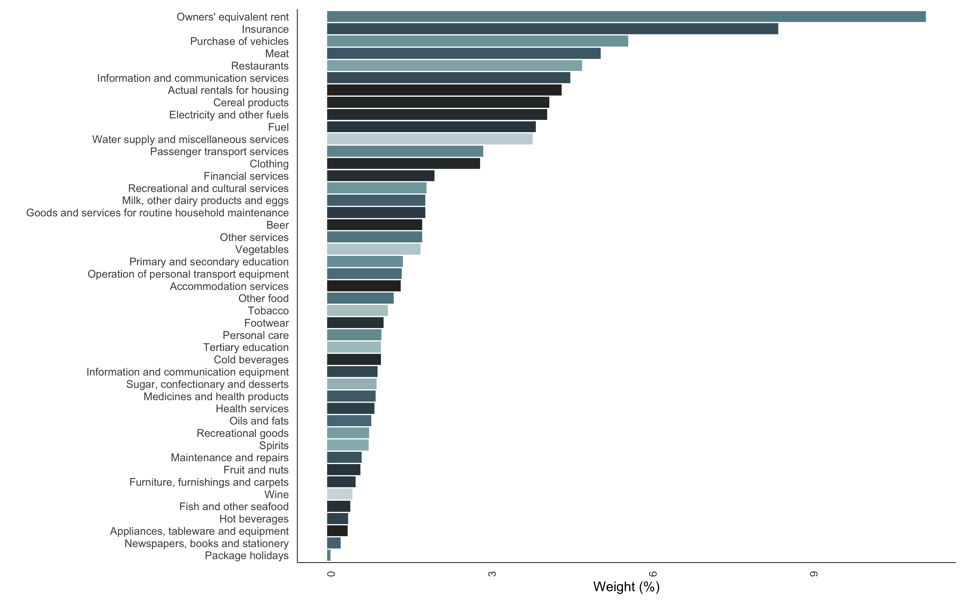
Figure 11: CPI Weights. Note: Due to a lack of data, some categories (no spirits; transport services of goods; household textiles; glassware, tableware, and house utensils; and Tools and equipment for house and garden) have been excluded.

Descriptive statistics
Table 2: Descriptive statistics
Goods category | Mean | Median | SD | Min | Max | Observations
Accommodation services | 4.47 | 4.55 | 4.43 | -8.16 | 20.79 | 203
Actual rentals for housing | 4.03 | 4.56 | 1.48 | 0.67 | 7.80 | 203
Appliances, tableware and equipment | 1.81 | 1.50 | 3.93 | -3.75 | 16.97 | 203
Beer | 6.07 | 5.72 | 2.85 | -0.25 | 13.19 | 203
Cereal products | 6.19 | 5.17 | 6.17 | -5.18 | 27.78 | 203
Clothing | 3.06 | 2.68 | 1.63 | 0.11 | 6.60 | 203
Cold beverages | 5.51 | 5.02 | 2.69 | -0.76 | 13.59 | 203
Electricity and other fuels | 11.78 | 10.66 | 6.19 | 2.28 | 30.99 | 203
Financial services | 5.82 | 5.43 | 2.96 | 2.51 | 20.00 | 203
Fish and other seafood | 6.54 | 6.43 | 3.22 | -1.47 | 20.74 | 203
Footwear | 2.45 | 2.16 | 1.40 | -0.22 | 5.77 | 203
Fruit and nuts | 4.75 | 4.25 | 6.16 | -8.18 | 25.36 | 203
Fuel | 6.51 | 7.33 | 15.01 | -26.78 | 56.28 | 203
Furniture, furnishings and carpets | -1.42 | -1.43 | 1.85 | -5.11 | 3.83 | 203
Goods and services for routine household maintenance | 4.88 | 4.76 | 1.44 | 1.32 | 9.03 | 203
Health services | 6.12 | 6.11 | 1.48 | 3.26 | 10.65 | 203
Hot beverages | 8.16 | 6.90 | 5.98 | -1.70 | 33.08 | 203
Information and communication equipment | -12.55 | -11.75 | 6.61 | -30.92 | 1.93 | 203
Information and communication services | 0.56 | 0.20 | 1.05 | -1.32 | 3.15 | 203
Insurance | 7.19 | 7.51 | 1.81 | 3.14 | 12.68 | 203
Maintenance and repairs | 4.09 | 3.85 | 2.84 | -0.80 | 17.53 | 203
Meat | 6.20 | 6.03 | 4.16 | -1.67 | 16.67 | 203
Medicines and health products | 5.05 | 4.46 | 2.31 | 1.97 | 15.53 | 203
Milk, other dairy products and eggs | 6.07 | 6.12 | 4.16 | -2.60 | 14.83 | 203
Newspapers, books and stationery | 6.81 | 6.56 | 3.03 | -3.72 | 13.50 | 203
Oils and fats | 6.17 | 4.21 | 10.55 | -14.55 | 37.67 | 203
Other food | 6.56 | 6.11 | 4.00 | -0.45 | 18.83 | 203
Other services | 4.28 | 3.40 | 3.83 | 0.31 | 19.47 | 203
Owners' equivalent rent | 3.69 | 3.92 | 1.25 | 0.56 | 6.98 | 203
Package holidays | 1.14 | 0.36 | 7.23 | -13.17 | 24.37 | 203
Passenger transport services | 5.67 | 3.15 | 5.75 | -3.09 | 23.67 | 203
Personal care | 4.51 | 3.86 | 3.68 | -1.07 | 15.93 | 203
Primary and secondary education | 7.60 | 7.64 | 1.98 | 3.42 | 11.80 | 203
Purchase of vehicles | 3.66 | 3.80 | 2.60 | -1.23 | 9.28 | 203
Recreational and cultural services | 3.77 | 2.24 | 4.64 | -0.11 | 21.58 | 203
Restaurants | 6.03 | 6.18 | 2.16 | 0.38 | 13.50 | 203
Spirits | 6.15 | 6.04 | 2.14 | 1.81 | 12.79 | 203
Sugar, confectionary and desserts | 8.51 | 7.80 | 5.06 | -6.03 | 21.61 | 203
Tertiary education | 6.48 | 6.11 | 2.52 | 0.00 | 9.85 | 203
Tobacco | 6.04 | 4.93 | 3.44 | 1.40 | 18.58 | 203
Vegetables | 6.89 | 5.72 | 6.65 | -5.14 | 23.59 | 203
Water supply and miscellaneous services | 7.77 | 8.02 | 1.79 | 4.38 | 11.23 | 203
Wine | 5.97 | 5.93 | 1.68 | 1.47 | 10.35 | 203
Core Inflation | 4.57 | 4.54 | 1.13 | 2.50 | 8.46 | 203
Headline Inflation | 5.13 | 5.17 | 1.32 | 1.93 | 8.41 | 203
Operation of personal transport equipment | 5.37 | 4.94 | 2.44 | 0.52 | 14.60 | 203
Recreational goods | 0.42 | 0.39 | 3.83 | -8.23 | 12.51 | 203

Stationarity tests
Table 3: Stationarity tests results
Measure | ADF test (p-value) | PP test (p-value) | KPSS test (p-value) | Stationarity
Headline Inflation | 0.14 | 0.20 | 0.04 | Stationary
RPD | 0.08 | 0.31 | 0.01 | Stationary

Lag length selection
Table 4: RPD lag length selection
Tests | Optimal Lags
AIC(n) | 3
HQ(n) | 3
SC(n) | 1
FPE(n) | 3

Appendix: Explanation of the quantile-on-quantile regression
To further capture the dynamic dependencies in the data, we perform a quantile-on-quantile regressions. Quantile regressions address the limitations of OLS which only estimates the mean dependency between on or more independent variables and the dependant variable. Distribution moments, such as the mean, can be strongly affected by heavy tails (or tail behaviour), non-linearity and extreme values in general (see Koenker 2017). In response to these limitations, the quantile regression was first introduced by Koenker and Bassett Jr (1978). Koenker (2017) notes that quantile regressions are inherently local and are immune to small deviations in distributions.
However, Gupta et al. (2018) note that standard quantile regressions are limited in their ability to capture dependency in its entirety. That is, although quantile regressions capture the relationship between two variables (for example) at various points of the conditional distribution, it restricts the possibility that the nature of the independent variable can also influence how the independent variable is calculated. The quantile-on-quantile regression (QQR), therefore, offers a more complete picture of the complex dependency structure, and was utilised numerous times in the literature (see Mishra et al. 2019; Chang et al. 2020; Sim 2016).
Given this brief explanation on QQR, we estimate the relationship between the $θ$-quantile of RPD ($a_{2t}$) and the $τ$-quantile of headline inflation ($Γ_{t}$) as follows:
$$a_{2t}=β^{θ}Γ_{t}+ϵ_{t}^{θ}, \left(18\right)$$
Taking the linear version of $β^{θ}\left(.\right)$ with a first order Taylor expansion of $β^{θ}\left(.\right)$ around $Γ^{τ}$ gives:
$$β^{θ}\left(Γ_{t}\right)≈β^{θ}\left(Γ^{τ}\right)+β^{θ'}\left(Γ^{τ}\right)\left(Γ_{t}-Γ^{τ}\right) \left(19\right)$$
In this instance both $β^{θ}\left(Γ^{τ}\right)$ and $β^{θ'}\left(Γ^{τ}\right)$ are indexed to $θ$ and $τ$. This means that Equation 19 can be summarised as follows:
$$β^{θ}\left(Γ_{t}\right)≈β_{0}\left(θ,τ\right)+β_{1}\left(θ,τ\right)\left(Γ_{t}-Γ\right), \left(20\right)$$
and collecting terms gives and substituting into Equation 18 results in:
$$a_{2t}=β_{0}\left(θ,τ\right)+β_{1}\left(θ,τ\right)\left(Γ^{τ}\right)\left(Γ_{t}-Γ\right)+ϵ_{t}^{θ} \left(21\right)$$
where $β^{θ}\left(Γ^{τ}\right)$ and $β^{θ'}\left(Γ^{τ}\right)$ are substituted with $β_{0}\left(θ,τ\right)$ and $β_{1}\left(θ,τ\right)\left(Γ^{τ}\right)$ respectively.
Therefore, Equation 21 captures the relationship between the $θ$-quantile of the RPD and the $τ$-quantile of inflation, that is, the overall dependence structure of the respective distributions. To this end, to get the estimates of $\hat{β_{0}}\left(θ,τ\right)$ and $\hat{β_{1}}\left(θ,τ\right)$ we solve for:
$$\min_{b_{0},b_{1}}\sum_{i=1}^{n}{ρ_{θ}}\left[a_{2t}-b_{0}-b_{1}\left(\hat{Γ_{t}}-\hat{Γ}\right)\right]K\left(\frac{F_{n}\left(\hat{Γ_{t}}\right)-τ}{h}\right) \left(22\right)$$
where $ρ_{θ}$ is a tilted absolute value function which produces $θ$-quantile values of $a_{2t}$. A Gaussian kernel $K\left(.\right)$ is used to weight observations in the neighbourhood of $\hat{Γ^{τ}}$ using $h$ as a bandwidth. These weights are inversely related to $\hat{Γ_{t}}-\hat{Γ}$. Lastly, the choice of $h$ remains uncertain in kernel regression where if a small $h$ is chosen the bias of the estimates is smaller but the variance of these estimates increases, and conversely. To overcome this uncertainty, we use the cross-validation method to calculate the appropripate level of $h$.

Corresponding author. National Treasury, South Africa. Email: Keagile.Lesame@treasury.gov.za
Economic Research Department, South African Reserve Bank. Email: xolani.sibande@resbank.co.za.
Relative price dispersion is the phenomenon where firms charge different prices for similar goods and services and these differences in price are persistent and account for a sizable portion of the variation in the price of the similar good and services in the same market. As a result, some firms overproduce and others underproduce compared to optimal production levels, leading to inefficient production or inefficient allocation of resources across firms which taken collectively means the economy is not producing optimally. Price signals direct labour and capital to their most efficient uses when prices diverge inefficiently across producers of similar goods, those signals are corrupted.
In signal extraction models, the effect of unexpected inflation on RPD depends on the magnitude not the sign and the effect is symmetric around zero inflation resulting in a U-shaped relationship.
In monetary search model developed by Head and Kumar (2005), inflation affects relative price dispersion through two closely related channels arising from search frictions and market power. In their model, there are two groups of buyers, those who observe only one price (incomplete information) offered by sellers and those that observe more than one price. Since an increase in inflation reduces purchasing power of fiat money held by buyers, this weakens their bargaining position in the market while increasing sellers’ market power. In this case, the Friedman rule is optimal. If, however, buyers observe multiple price quotes, an increase in inflation from a low rate increases the gains to search weakening sellers’ market power, compresses the distribution of prices, raising welfare as a result the optimal inflation rate is in region above zero inflation implying a nonlinear relationship between inflation and RPD. The SARB’s inflation forecasts and expectations in 2024 increasingly clustered around the lower half of the 3-6 band, e.g. “Moving to inflation, headline eased to 4.4% in August, a 3-year low, and close to the middle of our target range. Our forecast suggests this progress will be sustained, with inflation contained below the 4.5% midpoint of our range through to the end of the forecast horizon” according to the September 2024 Monetary Policy Statement (MPC). The SARB signalled its preference for 3 per cent target in the May 2025 MPC when it modelled a scenario with a 3 per cent inflation objective before explicitly incorporating the 3 per cent inflation target in its baseline forecasts in the July 2025 MPC.
The SARB’s inflation forecasts and expectations in 2024 increasingly clustered around the lower half of the 3-6 band, e.g. “Moving to inflation, headline eased to 4.4% in August, a 3-year low, and close to the middle of our target range. Our forecast suggests this progress will be sustained, with inflation contained.
The data is available at: The data is seasonally adjusted.
We use bootstraps with 500 replications to obtain confidence intervals for the non-parametric estimates.
Menu cost models generally find the optimal inflation rate to be 0 per cent and studies that consider the zero-lower bound constraint, measurement bias in inflation measure and downward wage rigidities generally propose an optimal inflation rate that are positive at near 2 per cent

